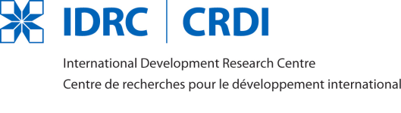

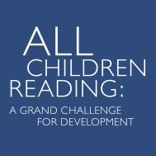

GUIDEBOOK ON DIGITAL GAME DEVELOPMENT
FOR EARLY LITERACY LEARNING IN DEVELOPING COUNTRIES

Appendix A

GENERAL INFORMATION FORM

GENERAL INFORMATION
Project Title:
Project Duration (in months): Must include time necessary for all activities paid with grant funds to take place.
Must not exceed 8 months.
Country/countries in which research will take place:
PROJECT LEADER
Full name:
Institutional affiliation:
Position in the institution:
Mailing address:
Telephone number/s (include country and area codes):
E-mail address:
PROPOSING INSTITUTION (if any). The proposing institution receives and administers grant funds.
Legal name:
Mailing address:
Telephone number/s (include country and area codes):
E-mail address:
Website address:
COLLABORATING INSTITUTION/S (if any). Collaborating institutions are those that are jointly proposing research in collaboration with the proposing institution and will each directly receive grant funds.
1. Legal name:
Mailing address:
Telephone number/s (include country and area codes):
E-mail address:
Website address:
2. Legal name:
Mailing address:
Telephone number/s (include country and area codes):
E-mail address:
Website address:
PARTICIPATING INSTITUTION/S (if any). Participating institutions are those that will participate directly in the conduct of the research but will not directly receive grant funds.
1. Legal name:
Mailing address:
Telephone number/s (include country and area codes):
E-mail address:
Website address:
2. Legal name:
Mailing address:
Telephone number/s (include country and area codes):
E-mail address:
PRINCIPAL INVESTIGATORS
In the space provided below, list the full name, institutional affiliation, position in the institution and email address of the principal investigators. For each of the principal investigators listed, submit the following documents:
1. A curriculum vitae (not more than three pages) with the following information:
a. Full name
b. Institutional affiliation and position in the institution
c. Mailing address, telephone number/s and email address
d. Educational qualifications from most recent to least recent
e. Employment history from most recent to least recent
f. Bibliographical citations of five publications that are most related to the proposed research
2. At least two samples of related work (e.g., published articles, research reports, academic/technical papers, policy papers, etc.)
1.

2.

3.

4.

5.

SIGNATURE OF PROJECT LEADER OVER PRINTED NAME
DATE:

