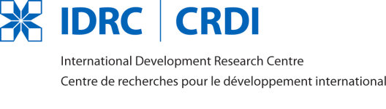
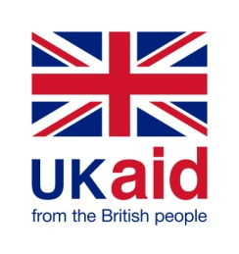
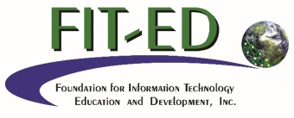

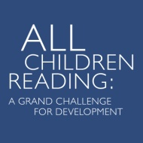
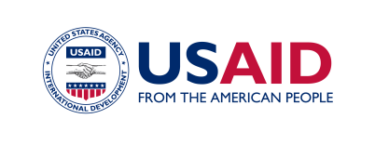
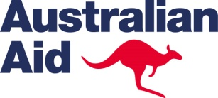
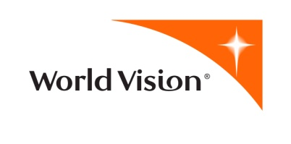

CALL FOR PROPOSALS

for research on the

Total Reading Approach for Children Plus (TRAC+) Project, Cambodia

Released by: Digital Learning for Development (DL4D)

and All Children Reading: A Grand Challenge for Development (ACR-GCD)

Released Date: 29 March 2016

Closing Date: 5:00 PM UTC/GMT+8 (Philippine Time), 25 April 2016

CONTENTS
- DL4D and ACR-GCD
- The TRAC+ Project
- Research themes and indicative research questions
- Funding scope and duration
- Eligibilities
- Selection criteria
- Selection process
- Selection timeline
- Proposal requirements and format
- Submission process
- Country clearance requirements
- Standard grant conditions
- Permission for use and disclosure of information
Appendix A: TRAC+ Project Overview
Appendix B: List of Eligible Countries
Appendix C: General Information Form
Appendix D: Cost Proposal Form

1. DL4D and ACR-GCD

Digital Learning for Development (DL4D) is part of the Information Networks in Asia and Sub-Saharan Africa (INASSA) program funded jointly by the International Development Research Centre (IDRC) of Canada and the Department for International Development (DFID) of the United Kingdom, and administered by the Foundation for Information Technology Education and Development (FIT-ED) of the Philippines.

DL4D aims to improve educational systems in developing countries in Asia through testing digital learning innovations and scaling proven ones. Specifically, it seeks to:

- Better understand how digital learning innovations contribute to improved educational equity, quality, and efficiency in developing countries in Asia;
- Foster international collaboration and partnerships on digital learning innovation research in developing country contexts in Asia and the rest of the world in order to expand the reach, scope, and impact of the DL4D network; and
- Scale proven digital learning innovations through contributing to educational policy-making and action at national and sub-national levels in developing countries in Asia.

All Children Reading: A Grand Challenge for Development (ACR-GCD) seeks to identify and analyze the effects of technology on early grade literacy rates in developing countries to optimize the allocation of resources, inform decisions, and enhance solutions. Launched in 2011 by the United States Agency for International Development (USAID), World Vision, and the Australian Government, it is an ongoing series of competitions that leverages science and technology to create and apply scalable solutions to improve literacy skills of early grade learners in developing countries.

2. The TRAC+ Project

In response to disappointing national literacy scores among grade school children in Cambodia, the Total Reading Approach for Children (TRAC) Project was implemented in eight rural, semi-urban, and urban primary schools in three Cambodian provinces over a two-year period (2013-14). A total of 2,352 children directly benefited from project interventions.

TRAC applied an integrated approach to improve early grade reading outcomes among Grade 1 and Grade 2 pupils. Project components included: (1) School leadership training, (2) reading benchmarks, (3) literacy coaches, (4) parental engagement, (5) peer tutoring, (6) reading toolkit, as well as (7) m-Learning, which utilized an Android mobile application created by Education Technology for Development (ET4D) to teach reading in Khmer with a phonic pedagogy. By creating a total learning environment, TRAC was believed to enhance the ability of children to acquire essential early reading skills while encouraging a culture of reading both in school and at home.

TRAC’s innovative and holistic system showed promising results, with over 90 per cent of performance indicators successfully achieved. For instance, 83% of assessed teachers used the benchmark system following standard implementation criteria. Parental surveys indicated that, even though parental engagement was challenging, more than two-thirds of assessed parents borrowed literacy enhancement materials (from the reading toolkits provided to each school) at least once a month or more. User surveys indicated relatively high rates of usage of the m-Learning app, with 70% of surveyed parents indicating that they used the devices with their children at least once a month or more.

The three-year Total Reading Approach for Children Plus (TRAC+) Project, which began in December 2014, builds on the success of TRAC. TRAC+ is being implemented in13 World Vision area development programs in five provinces of Cambodia. During Year 1, TRAC+ ran in 170 schools and will continue working in 139 of the 170 original target schools in Year 2. Over the life of project, TRAC+ is expected to directly reach about 20,000 students.

Further details on TRAC+ implementation may be found in Appendix A.

3. Research themes and research questions

Eligible research institutions (see Section 5) are invited to submit proposals to conduct a collective case study of m-Learning in a naturalistic setting within the existing project cycle of TRAC+. The main research question to be addressed is: "How and to what extent does the integration of m-Learning in TRAC+ enhance the literacy of early grade students?"

Research to be supported by this Call must contribute to the body of knowledge on the effectiveness, sustainability and scalability of m-Learning integrated into TRAC+ in the Cambodian primary school context. Equity and efficiency issues should also be addressed. Some indicative sub-questions are provided below.

Localization
- What curricular, pedagogical, technological, organizational, economic, and socio-cultural issues must be considered in designing, developing and implementing effective m-Learning in the Cambodian primary school context? How can these issues be addressed?

Effectiveness
- How, to what extent, and in what contexts does m-Learning integrated in TRAC+ enhance learner engagement?
- How, to what extent, and in what contexts do m-Learning improve learning outcomes in literacy? What particular learning outcomes and under what conditions?
- Are there differential effects across levels, settings, types of learners, level of technology integration, type and level of complementary non-technology interventions, etc.? If so, what factors account for these differences?
- What are the parameters and requirements for teacher professional development and professional learning in relation to m-Learning integrated into TRAC+? What strategies may be employed to meet these requirements?

Sustainability
- What are the drivers and barriers to sustaining effective m-learning in diverse primary school contexts in Cambodia?
- What are the human, infrastructural, technical, organizational, and financial requirements for achieving sustainability?
- What strategies can be employed to increase the capability of stakeholders to sustain effective m-learning for early grade literacy?

Scalability
- What are the key issues in scaling up effective m-Learning in the Cambodian primary school context? How can these issues be addressed effectively?
- What other e-learning resources exist that might contribute to a stronger e-learning framework in Cambodia?

Equity
- How, to what extent, and in what contexts does m-Learning integrated into TRAC+ broaden access to literacy education in the Cambodian primary school context? For whom and under what conditions?
- Are there any differences in participation in m-Learning integrated into TRAC+ based on gender? Are benefits and risks the same for males and females? What factors contribute to any gender-based differences?
- What strategies can be employed to achieve greater inclusion?

Efficiency
- Is m-Learning integrated into TRAC+ more cost-effective in the Cambodian primary school context than comparable traditional interventions? What are the tradeoffs? Given these tradeoffs, under what conditions is m-Learning desirable?
- How and to what extent does m-Learning integrated into TRAC+ improve the fit between education and societal needs and aspirations in the Cambodian primary school context?

4. Funding scope and duration

A grant of up to Two Million Five Hundred Thousand Philippine Pesos (PHP 2,500,000 or approximately USD 54,000) will be awarded to the approved research proposal under this Call, subject to the availability of funds.

The research project must not exceed 10 months, including all research activities and final reporting. The project is expected to begin in July 2016; activities must be planned accordingly.

5. Eligibilities

- The proposing institution must be registered in Asia (see Appendix B for the List of Eligible Countries). Institutions from developed Asian countries must have at least one institutional partner from Cambodia. South-south and north-south collaborations will be given preference.
- Grant funds must be used primarily for research activities and not for developing a digital learning solution or resource, nor for acquiring hardware and software.
- Fluency in oral and written Khmer is preferred. As a minimum, at least one member of the research team must be a fluent in oral and written Khmer.

6. Selection criteria

Proposals will be assessed against criteria described in Table 1 below.

Table 1. Selection criteria
Criterion | Weight (%)
Problem formulation, objectives and relevance  - well-defined and articulated problem statement related to educational quality, equity, and/or efficiency  - well-developed and realistic objectives based on defined problem  - clear articulation of the intended users and uses of the research outputs  - relevance of study to TRAC and m-Learning | 10
Theoretical foundation and literature review  - robustness and appropriateness of the theoretical approach  - critical review of up-to-date knowledge on the topic  - clear justification for the study as a way of addressing the problem | 10
Research methods  - adequacy and appropriateness of study design to achieve the research objectives  - clear description of methods and rigor and appropriateness of methods for data gathering and analyses  - feasibility of the study including the accessibility of participants | 25
Sustainability and/or scalability  - clear articulation of potential sustainability and scalability issues in the specific contexts involved  - adequacy of methods assessing the potential for sustaining and/or scaling up the innovation being studied | 10
Knowledge transfer and capacity building  - clarity and practicality of plans for knowledge transfer and capacity building between project partners, between project partners and their local communities, and between the project partners and the rest of the DL4D network | 10
Project leaders  - suitability of the project leaders’ expertise and experience  - credible track record of the project leaders in the proposed theme  - experience of the project leaders in managing complex projects including strong administrative, communication, and collaboration skills | 10
Work plan and budget  - clarity and soundness of the work plan, with activities matched to objectives  - clear deliverables and a realistic time frame  - reasonableness, realism and completeness of proposed costs | 25

7. Selection process

Proposals submitted under this Call will be reviewed and assessed by a panel of specialists. Final funding decisions based on the review and recommendations of the Panel will be made jointly by FIT-ED, IDRC, World Vision and USAID. Proposals will be either accepted or rejected. The accepted proposal may receive specific comments from the Panel which the proposing institution is required to satisfactorily address before the grant is awarded and a grant agreement signed. FIT-ED reserves the right to cancel the grant application process at any time without prior notice and/or to not award a grant under this process at its discretion.

8. Selection timeline

- Release of Call for Proposals – 29 March 2016
- Deadline for submission of proposals – 25 April 2016, 5:00 PM UTC/GMT +8 (Philippine time)
- Review of full proposals by the Panel – 26 April to 6 May 2016
- Panel review results communicated to applicants – 9 May 2016
- Proposal revision and finalization/Internal project approval and granting processes –10 May to 1 July 2016
- Project commencement date – 4 July 2016

9. Proposal requirements and format

Applicants are required to submit a 1) technical proposal and 2) cost proposal, along with a completed General Information Form (Appendix C)

Technical proposals must include the following sections:
- Title page
- Table of contents
- Abstract (start page 1 here)
- Statement and justification of the research problem
- Objectives and research questions
- Review of related literature and conceptual framework
- Methods
    - design
    - data collection: subjects, instruments, procedures
    - data analysis
    - gender considerations and analysis
    - ethical considerations
- Workplan: Objectives, activities, outputs, and timetable (Month 1, Month 2, …, Month 12)
- Open access dissemination plan (see Section 12)
- Risks and mitigating actions
- References
- Annexes

Required annexes
- A one-page profile of all institutions involved in the research project (proposing, collaborating, and participating).
- A past performance profile of the proposing institution listing up to five programs or projects within the past five years that are related to the research project being proposed.
- A description of the roles, responsibilities, and time commitments of key personnel
- Detailed CVs of the Project Leader/Principal Investigator and all other Principal Investigators. CVs must include a listing of related research and publications.
- Selected samples of related work (e.g., published articles, research reports, academic/technical papers, policy papers, etc.) of each Principal Investigator.

Technical proposals must directly address each of the selection criteria listed in Table 3.

Technical proposals must be written in English. They must not exceed 10 pages (excluding the title page, table of contents, references, and annexes), formatted as follows:

paper size: 8-1/2” x 11”

margins: 1" all around

font: Calibri, 11 points

spacing: single

pagination: continuous, starting at page 1 on the abstract page

Pages that exceed page limits will not be evaluated.

Cost proposals must be presented using the Cost Proposal Form (Appendix D)

10. Submission process

Full proposals (technical and cost) with all the required annexes must be submitted by email to dl4d@fit-ed.org on or before 5:00 PM UTC/GMT+8 (Philippine Time), 25 April 2016. Incomplete proposals or proposals received after this deadline will not be considered.

All enquiries regarding this Call should be directed to vltinio@fit-ed.org.

11. Country clearance requirements

IDRC has conducted general agreements for scientific and technical cooperation with a number of governments. These agreements establish the framework for IDRC cooperation with that country by defining the rights and obligations of both IDRC and the government. As such, any applicant institution selected to receive funding may be required to obtain country approval in accordance with these agreements prior to receiving funding from IDRC. Prospective applicants are encouraged to familiarize themselves with their respective country clearance requirements and take these into account in their research planning.

12. Open access policy

IDRC believes that publicly funded research should be freely and openly available. All IDRC-funded projects must adhere to IDRC’s open access policy, which may be viewed at http://www.idrc.ca/EN/Misc/Pages/Open-Access-Policy.aspx. Research proposals submitted to IDRC must include an open access dissemination plan.

13. Permission for use and disclosure of information

By submitting a proposal under this call, the applicant consents to the disclosure of all submitted documents to the Technical Panel and others from FIT-ED, IDRC, DFID and third parties who are involved in the review and selection process. If selected for funding, the applicant further consents to the disclosure of the name of the applicant, the name of the team leader, and the title of the proposed project in any announcement of selected projects.

http://www.et4d.com/

